LCP 10: Journey to Mars
Journey to Mars: The Physics of Traveling to the Red Planet
This LCP is based on the article “Journey to Mars: The physics of travelling to the red planet”, (written with John Begoray) which was published by the British journal Physics Education in 2005. It can be downloaded from my website. This LCP is essentially a text that provides information about the history of the efforts made in finding the age of the earth and the sun. It goes beyond conventional approaches by inviting the reader to follow the arguments and the calculations made in detail. We have also developed an interactive computer program (ICP) that should be looked at and an effort made to master it. The ICP program called “Journey to Mars” can be downloaded from two websites: IL 1 and IL 2.
IL 1 *** Contextual-Humanistic Approaches to Teaching Science
(www.Sci-Ed.ca)
IL 2 *** University of Manitoba Crystal web site.
(http://www.umanitoba.ca/outreach/crystal/physics.html)
There are no explicit Questions and Problems sections here as in the previous LCPs. However, the text should provide the physics instructor with a rich background from which to set tasks for students that involve them in becoming acquainted with the history of the importance of Mars in our understanding of the solar system as well as with the physics of the trajectories travelling to a planet.
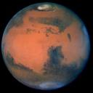
Fig.1: Picture of Mars as seen by the Hubble telescope

Mars has fascinated mankind since antiquity. Plato set the question that guided the thinking of ancient astronomers. The question was prompted by the retrograde motion of the red planet (see Fig.1) and provided the impetus for the earth-centered solar system of Ptolemy, and fifteen hundred years later, for the sun-centered solar system of Copernicus. Kepler’s laws of planetary motion were the result of his all-out “war on Mars” that lasted for about 18 years. Fascination for Mars reappeared in the beginning of the last century with the astronomer Percival Lowell’s well publicized claim that intelligent life was responsible for the “canals” that were sighted with a new powerful telescope. We are seeing a resurgence of this interest in the wake of many successful attempts to land on Mars in the last 30 years to study the surface and the atmosphere of the planet. Indeed, the Canadian Space Agency (CSA) is now cooperating with NASA in the quest for a full scale scientific assault on the red planet. In response to this new interest, we wrote an interactive computer program (ICP), illustrating the physics of planetary motion that we have used successfully in lecture-demonstrations and with students in classrooms. The main part of the article describes two missions to Mars, and a third one that illustrates the capabilities of the ICP.

Fig. 2: Plato (424-347) and Aristotle (384-324) . From the “School of Athens”
by Rafael. Plato points toward the sky and asks the question:
What circular
motion and constant speed would produce the observational phenomena
in the heavens?


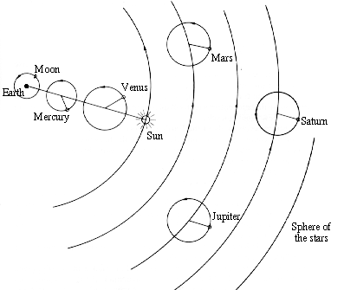

Fig. 3: Ptolemy (85-165 AD) His answer to Plato’s question: The geo-centric solar system


Fig 4: Copernicus (1473-1543) The Sun resides at the center majestically unmoving.

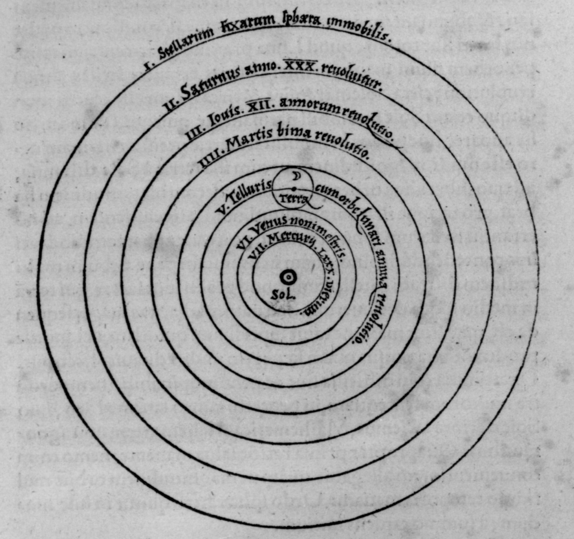
Fig 5: The solar-centered planetary system of Copernicus, as shown in his book De Revolutionibus, published in 1543, shortly after his death.

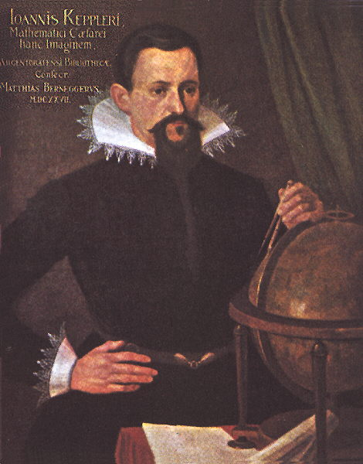
Fig. 6: Kepler (1571-1630)

“By the study of the orbit of Mars, we must either
arrive at the secrets of astronomy, or forever remain in
ignorance of them”

Introduction
Studying the motion of the “wanderers” in the sky , especially the retrograde meandering
of Mars, provided the impetus for challenging the astronomers in ancient Greece to find a model for the solar system. Plato’s injunction “By the assumption of what uniform and ordered motions can the apparent motions of the planets be accounted for?”, eventually resulted in the Ptolemaic earth-centered solar system, five hundred years later.

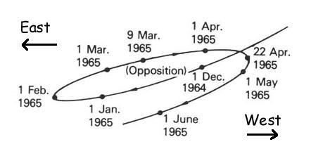
Fig. 7: The motion of Mars, during its retrograde motion of 1965.

As noted in the diagram, such motion occurs at opposition, when Mars is opposite the Sun in the sky, and rises near sunset. (slightly modified from IL 3.)
IL 3 *** Exploration of Mars 1958 – 1978
(http://history.nasa.gov/SP-4212/ch1.html)

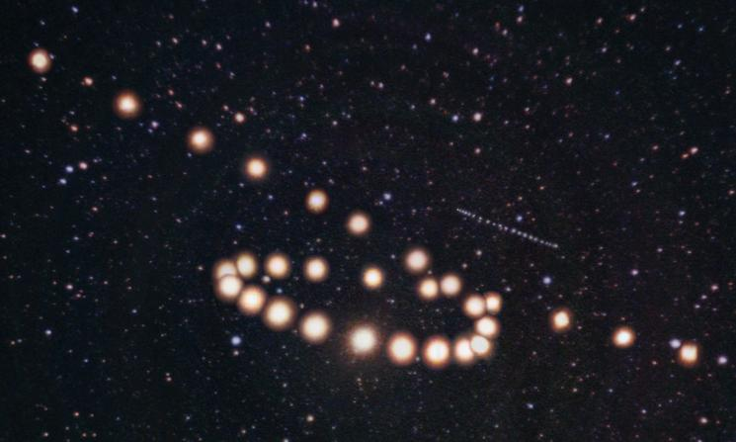
Fig. 8: Retrograde motion of Mars as actually photographed over a period of two months

IL 4 ** An applet to show Ptolemy’s explanation of retrograde motion.
(http://zebu.uoregon.edu/2003/hum399/canim.gif)

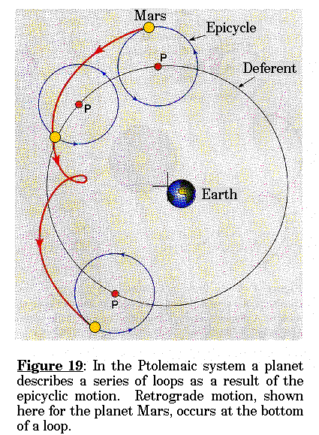.
Fig. 9: Ptolemy’s explanation of the retrograde motion of Mars. The motion of Mars as seen from the frame of reference of the earth.

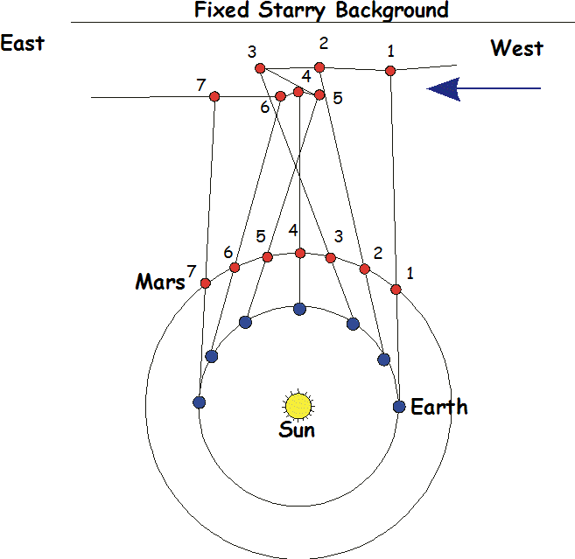
Fig. 10: Copernicus’ explanation of retrograde motion, as seen from the frame of reference of the sun.

Copernicus, some fourteen hundred years after Ptolemy, studied the motion of Mars carefully and argued for a sun-centered solar system where all planets moved in circular orbits. Using this model, the retrograde motion of Mars, as well as the phases of Venus were easily accounted for. Kepler, in an attempt to improve on Copernicus’ model of circular motion, showed in his 18 year “war on Mars”, that the planet’s path was elliptical and not circular. Newton then used Kepler’s laws of planetary motion to corroborate his inverse square law of gravitational attraction.
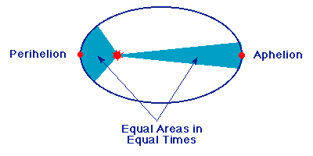
Fig. 11: Kepler’s laws of planetary motion

1. Law of elliptical orbits The planets move in elliptical orbits.
2. Law of Areas The planets sweep out equal areas in equal times. ΔA / Δt = Constant.
3. Law of periods (Harmonic Law) T² / R³ = Constant, where T is the period of the planet and R the average distance from the sun, given by ( R₁ + R₂ )/ 2.
Mars again captured the attention of astronomers around 1900, when the American astronomer Percival Lowell, using a new 21 inch telescope in Flagstad, Arizona, concluded that there where “man-made” canals on Mars. In 1908 he published a book “Mars as the Abode of Life” which caused a sensation in America and in Europe. Today we know that there are no such canals on Mars.

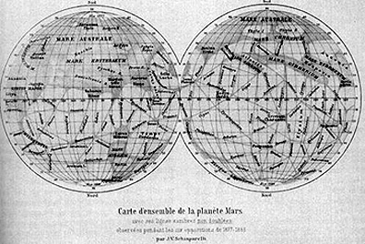
Fig. 12: Percival Lowell’s “Canals on Mars” (1900).
Since 1975, starting with the Viking missions, NASA has explored the planet, providing scientific information for almost six years. Since then there have been many visits to the planet, a brief search on the internet will attest to that.
The recent issue of the accessible British journal New Scientist (January 31-February 6, 2004), contained a special report “The Moon and Mars” in which the article “Destination Mars” is featured. This special report was published in response to the new interest in space exploration that the American president George Bush created last year with his support of a program that will have a human landing on Mars. He did not set a date, probably because George Bush senior set an unrealistic one (2020) some years ago.
Reading this article reminded us of a previous special issue of Scientific American that we used to write an interactive computer program (ICP) for our students for studying elementary celestial mechanics.

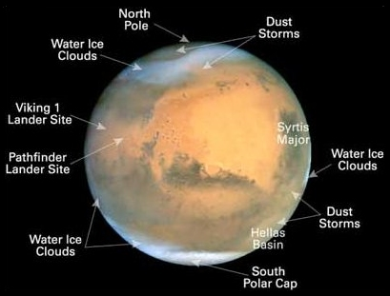
Fig. 13: Contemporary picture of Mars, showing Mars landings.
In the March , 2000 issue of Scientific American presented a special report entitled: “Sending Astronauts to Mars”. The articles were written by experts in the field of space travel and were sufficiently detailed so that it is possible to use the description and the data presented to map out a “large context problem” for high school and first year college students . This special issue provides a chance to develop an interesting and realistic context with a central “big idea” that attracts students’ interest and excites their imagination.
In one of the articles, space scientist Fred Singer briefly describes six possible scenarios to travel to Mars and in another, Robert Zubrin, president of the Mars Society, gives a sufficiently detailed description of the trajectories involved to generate interesting and realistic problems for an elementary physics class.
Finally, a recent report from the Globe and Mail (January 15, 2004), taken form the internet states that:
Space researchers and enthusiasts say Canada’s expertise and ambitions could dovetail nicely with U.S. president George W. Bush’s plans for using a lunar base as a launch pad for a manned Mars mission. The Canadian Space Agency’s (CSA) Marc Garneau, who on Tuesday said that the agency has its own plans for a Mars mission, ... “In Garneau’s eyes and the CSA’s eyes, Mars is a big target right now”, said Matt Bamsey, president of the mars Society of Canada”.
We are not attempting to describe the physics of launching a mission from the moon, but from the Earth directly. What we offer here is a text that should be read with the ICP activated..

IL 5**** The interactive computer program (ICP) we developed, (Journey to Mars).
(http://sci-ed.org/Mars/index.htm)

We will describe two missions to Mars, using the data given in the article as a guide for developing and solving of problems that can be discussed in an elementary physics class room. In Mission 1, we plan a trip to Mars based on a Hohmann orbit transfer (HOT) trajectory, that allows for a long stay on Mars, using minimum energy expenditure. This special transfer is discussed below. In addition, a third mission will be suggested that requires the use of the interactive program found using the ICP.
In Mission 2 we discuss landing on Mars for only a brief time, then returning to Earth on a different trajectory, thus cutting the total time of the trip by a considerable amount. For our study the trajectories for a 30 day stay will be described. This type of scenario was rejected by the Scientific American author because of the high energy consumption involved and the short time of actual stay on Mars such a trip would allow. However, the “hitchhiking” space trip is especially interesting to us for pedagogical reasons, because it allows for the development of an exciting interactive program that responds well to students’s ‘what if’ questions. Moreover, this exercise will liberate us from the constraint of the HOT trajectory, as we shall see.
We have added some details for a third trip that allows staying on Mars for 100 days, using the ICP and added some relatively simple calculations to describe it. We present this trip as an example of a study that students can make using our ICP.
Preliminary Calculations
Before discussing the two missions to go to Mars we require a few preliminary calculations in preparation for the planning of the trajectories. Most of these are straight-forward and can be found in introductory physics text books.
We make the following assumptions and use the following data:
1. The orbits of Earth and Mars are coplanar.
2. Radius of the orbit of Earth is 1.00AU, and for Mars it is 1.52 AU. (1 AU = 1.5x10¹¹m).
3. The period of the Earth and Mars are 365 d and 687d respectively.
4. The orbital speeds of the Earth and Mars are constant, 29.8 km/s and 24.1 km/s, respectively.
What is the escape velocity from Earth and from Mars?
The escape velocity from a planet is obtained by equating the gravitational potential energy from infinity to the surface to the kinetic energy required to overcome that potential energy.
½ m v_{esc}² = G mM_{planet} / R_{planet}
Substituting values for the Earth and Mars we obtain 11.2 km/s and 5.1 km/s respectively. These values will be important for our calculations.
½ m _{vesc}² = G mM_{p} / R_{p}
or v_{esc} = (2GM_{p} / R_{p}) )^{1/2}
v_{esc} = 5.1 km/s (Mars)
v_{esc} = 11.6 km/s (Earth)
What is the “gravitational sphere of influence”of Earth and of Mars?
When planning our trip to Mars we will need to know how far we must be before we can ignore the effect of the gravitational attraction of the planet (or how close before we must consider the gravitational effect of the planet).
The generally accepted distance for the Earth’s “sphere of influence” is about 9.2x10⁸ m, or more than twice the distance between the Earth and the Moon. The sphere of influence of Mars is about 5.7 x10⁸ m, or about 1 1/3 the distance between the Earth and the Moon. To calculate these values astronomers generally use the suggestion made by Laplace about two hundred years ago:
R_{SI} = D ( M_{planet} / M_{sun})^{2/5}
where D is the distance between a planet and the sun.. At this distance from the Earth, or from Mars, the gravitational attraction of the Earth or Mars should be negligible in comparison to that of the sun. We can easily check these values by using the inverse square law.
R_{SI} = D ( M_{p} / M_{s})^{2/5}
For the Earth: R_{SI} = 9.2x108 m, and
For Mars R_{SI} = 5.7 x108 m.
(Distance to the Moon is about 3.7x10⁸ m)
These values will become important when considering the motion of the space craft (SC) leaving the Earth and Mars or approaching them. Certain simplifying assumptions will have to be made when calculating the motion here, because the combined effect of the attraction of a planet and the Sun on the spacecraft is a very complicated problem and cannot be handled using elementary mathematics.
Data and assumptions
The Earth has an almost circular orbit but Mars’s orbit is more eccentric. For our calculations, however, we will assume that both orbits are circular, with radii equal to their respective semi-major axes, 1.00 AU and 1.52 AU, and also assume that their orbital velocities are constant (29.8 km/s for the Earth, and 24.1 km/s for Mars). (One AU, or Astronomical Unit, is the average distance between the Earth and the sun, or 1.50x10¹¹m, as shown in Fig.2) Moreover, since the inclination of Mars is only about 1.8 degrees to the orbit of the Earth we can safely consider the two orbits to be coplanar.

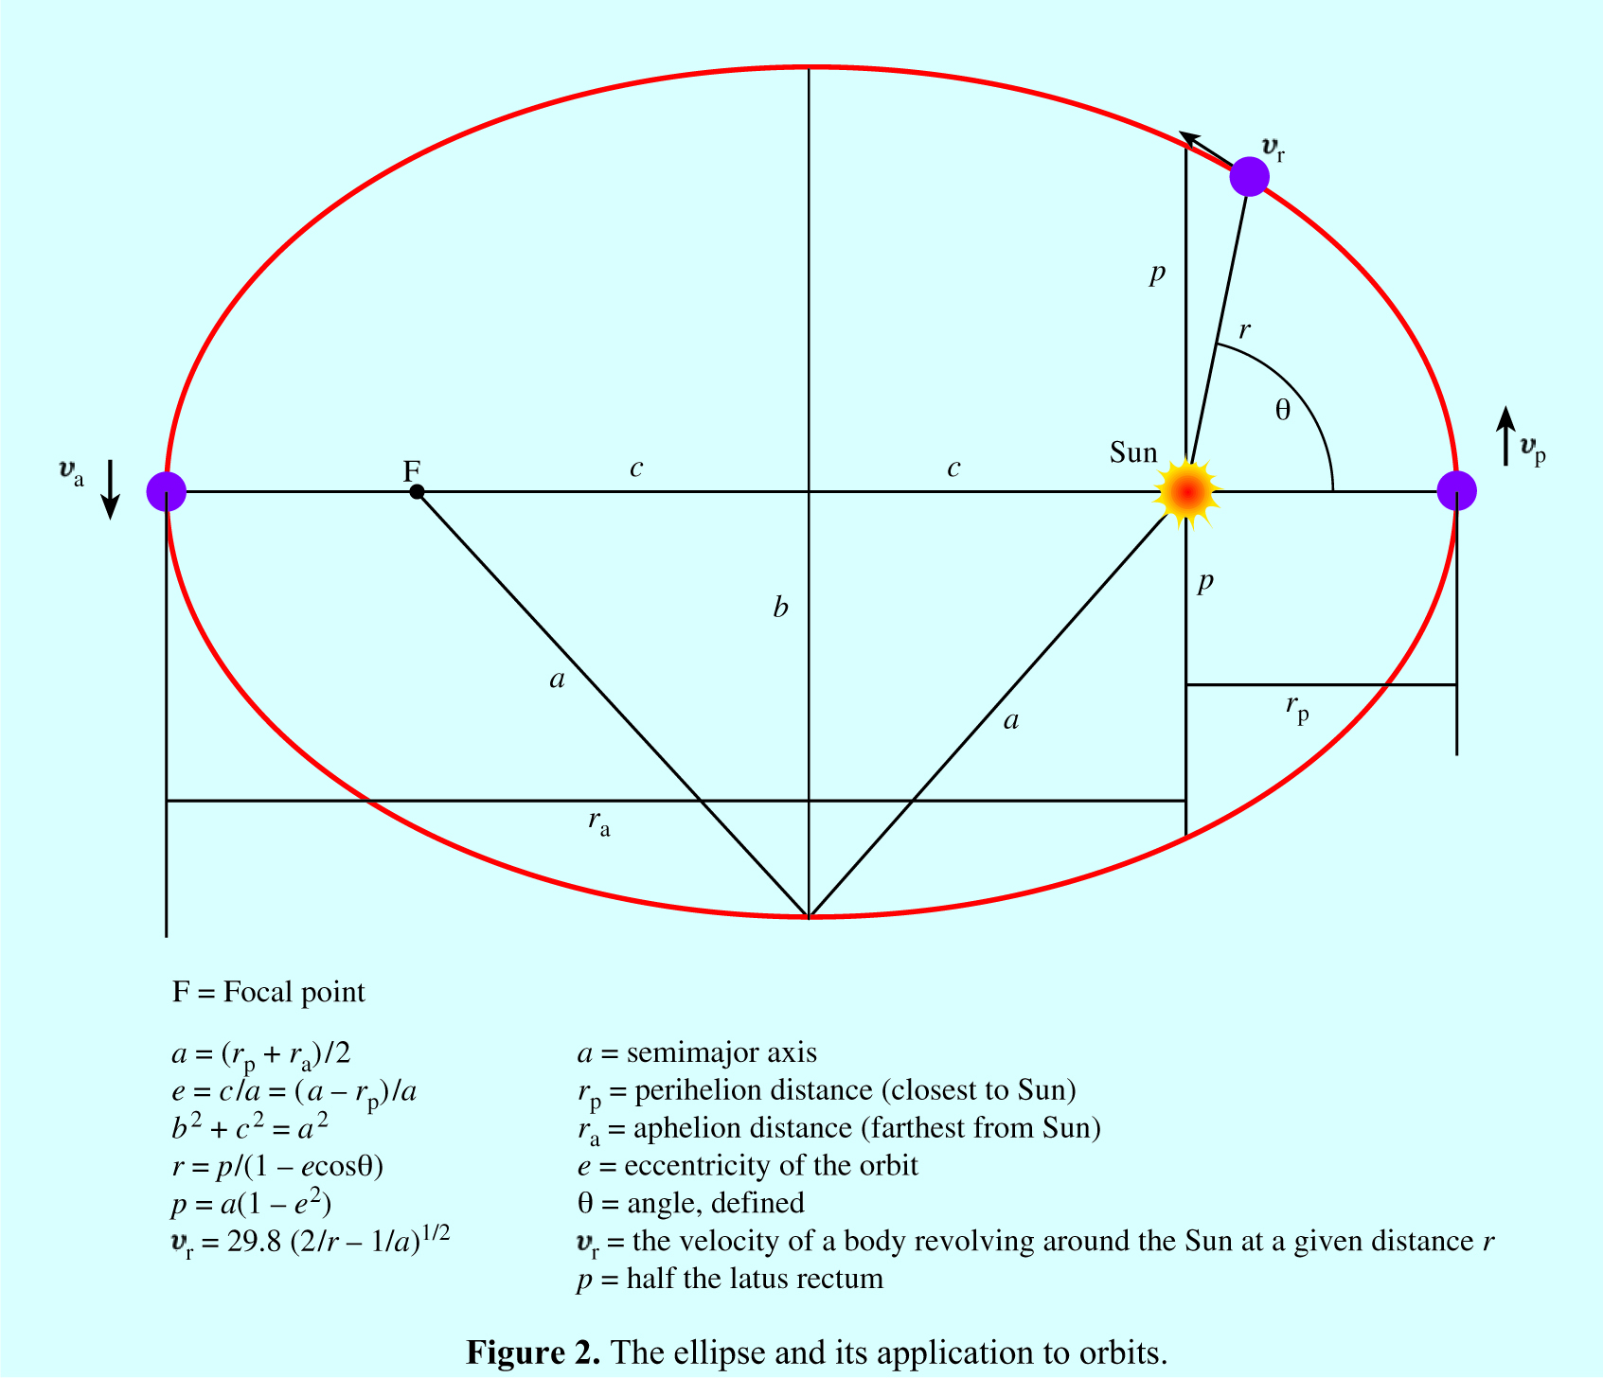
Fig. 14: The ellipse and its application to orbits.
The periods of the Earth and Mars will be taken as 365 d and 687 d, respectively. The period of Mars is calculated using Kepler’s third law in the form of P = 365 x a^{3/2}, where P is the period in days and a is the semimajor axis, given in Astronomical Units (AU). The semi-major axis of the Earth is then taken as 1.00 AU.
The following will be assumed for our calculation:
1. When calculating the perigee velocity (the velocity required when the SC leaves the earth) for
the HOT trajectory, we assume that the SC is beyond the “sphere of influence” of the earth.
That is, the calculation is made as if the earth did not exist.
2. When calculating the apogee velocity required to connect with the orbit of Mars, it is assumed
that the SC will be outside the “sphere of influence” of Mars. That is, the calculation is made as
if Mars did not exist.
3. To establish the energy budget for each trip, we use the delta V measure in km/s, following the
practice of NASA. We have to remember that when adding delta V’s, (ΔV) the absolute value
must be taken.
Videos:
ILV 1 **** Travelling to Mars
http://video.google.ca/videosearch?hl=en&q=travelling%20to%20mars&um=1&ie=UTF-8&sa=N&tab=wv#
See especially the following:
Disney's Mars & Beyond 6 of 6 - Travel to Mars
How did you prevent Beagle II from contaminating Mars? .
Mars Science Labaratory
[RM] Phoenix mission

Equations used for the problems:
- At any point on the orbit along the elliptical orbit the conservation of energy
principle requires that:
E_{Total} = E_{Kinetic} + E _{Potential}
or: E_{Total} = ½ mv² + GmM / r
It can be shown that :
E_{Total} = GmM / 2a
Then it follows that:
v_{r} = {GM (2 / r – 1/a)} ^{½}

(This is called the vis viva equation and is one of the most important equations for elementary celestial mechanics).
The equation can be written as:
v_{r} = 29.8 (2 / r – 1/a) ^{½} (km/s)
This form is more useful for us.
Notice that the vis-viva equation
v_{r} = {GMS (2 / r – 1/a)} ½ reduces to
v = {GM / r} ½ , when a = r
This is the simple equation of motion for a planet in a circular orbit that we study in grade 12 physics.
2. The time of transit (for Mission 2) along an ellipse is given by:
Area A swept out by r divided by the total area of the ellipse times the period of the planet:
t = {A / πab} P
T_{transit} = 365 a3/2 (E - e sin θ)/ 2 π,
where
E = cos⁻¹ ( e + cos θ)
(1 + e cosθ)

This is the modern form of an equation that Kepler developed and is called the “mean anomaly”.
See IL 6 below for the discussion of the Kepler equation.
IL 6 ** The Kepler equation of the “mean anomaly”.
(http://www.akiti.ca/KeplerEquation.html)

Again, for circular motion the formula reduces simply to
t = {θ / 2 π } P
This formula applies to circular motion and is discussed in high school physics.

Mission 1: Using a “HOT line” to Mars
In 1925, the German engineer-astronomer Walter Hohmann showed that the trajectory requiring the minimum energy to go to Mars would be the one shown in Fig.1. We are using the acronym HOT to indicate a “Hohmann Orbit Transfer” trajectory). Most trips to Mars so far have used the HOT trajectory method (See figure 15).
The HOT trajectory between two circular (or near-circular) orbits is one of the most useful maneuvers available to satellite operators. It represents a convenient method of establishing a satellite in high altitude orbit, such as a geosynchronous orbit. For example, we could first position a satellite in LEO (low-Earth orbit), and then transfer to a higher circular orbit by means of an elliptical transfer orbit which is just tangent to both of the circular orbits. In addition, transfer orbits of this type can also be used to move from a lower solar orbit to a higher solar orbit; i.e., from the Earth’s orbit to that of Mars, etc.

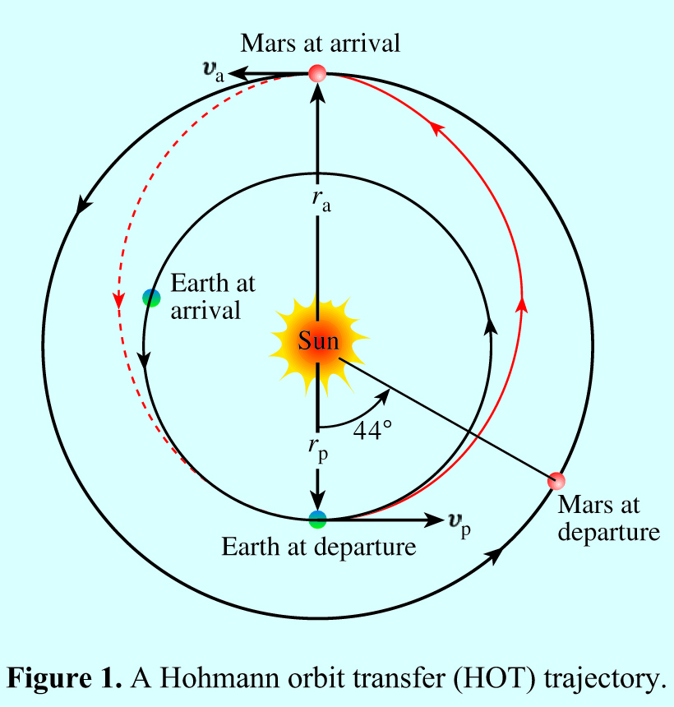
Fig. 15: A Hohmann orbit transport (HOT) trajectory.
The HOT trajectory requires the lowest energy. This can be shown by calculating the energy requirement of trajectories that would meet Mars at progressively later times. We have done this for trajectory that connects at 90°. This position is ideal for a straight-forward solution using the equations given in Fig.2. We find that the SC would need to follow a trajectory with a semi-major axis of 2.08 AU and an eccentricity of 0.52. The perihelion velocity required is 36.7 km/s and the velocity of the SC arriving in the vicinity of Mars is 27.2 km/s. Granted, the time of transit would be only 88 d, as compared to the 228 days needed for Mission 2. However, the delta V for this trajectory is clearly prohibitive: 18.1 km/s to place the SC into the trajectory and an additional - 8.2 km/s to land on Mars, for a total of 26.3 km/s.

We will see that the delta V for the HOT trajectory to get to Mars is only about 16.7 km/s. Since energy is proportional to the square of the speed, the short flight would be about 2.5 times higher. (We are also neglecting the fact that the SC approaches Mars at an angle of about 30° to the orbit of the planet, which increases the delta V value considerably). The HOT trajectory, therefore, is the longest but it is the least energy demanding choice.
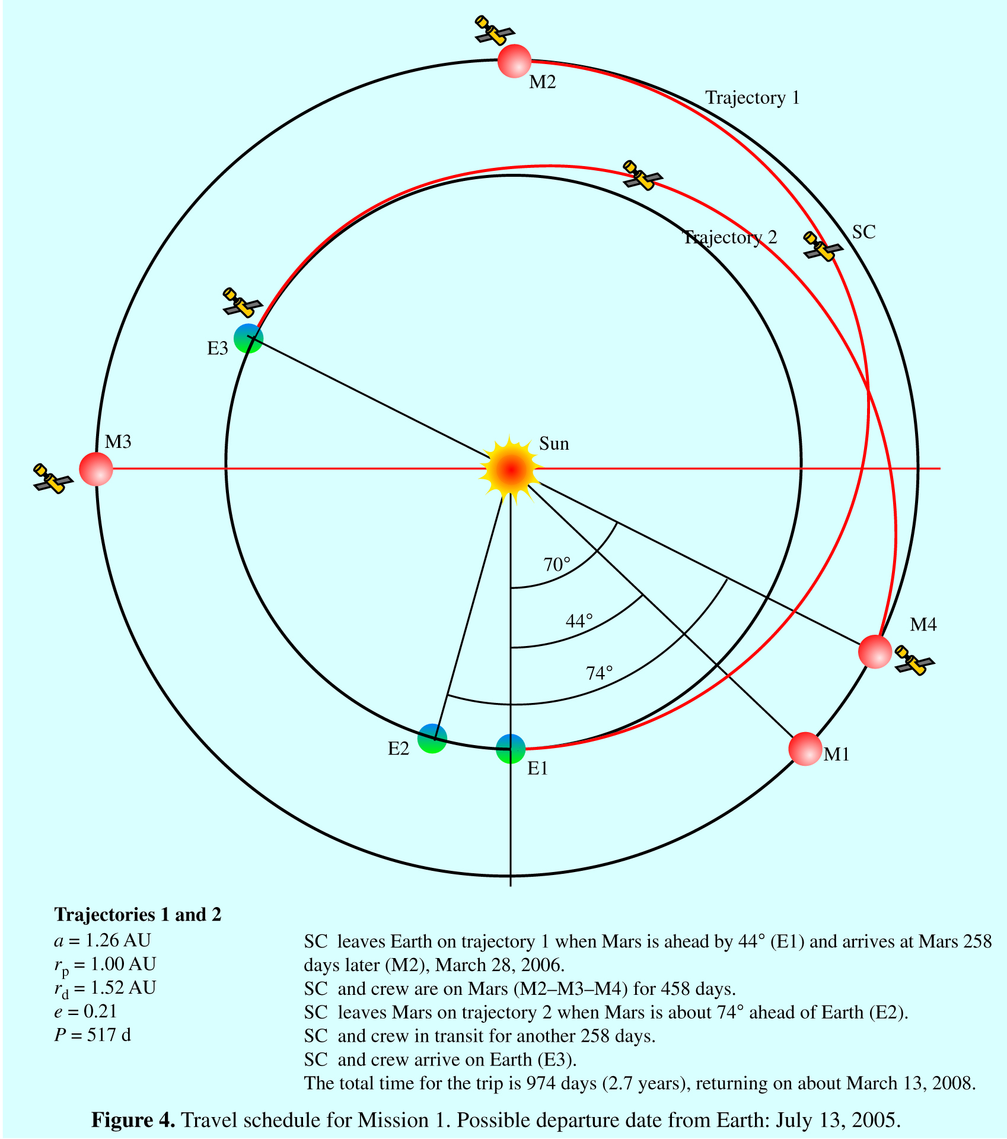
Fig. 16: Mission 1: In Mission 1 we plan a trip to Mars based on a Hohmann
orbit transfer (HOT) trajectory, that allows for a long stay on Mars,
using minimum energy expenditure.

Calculating the ellipse and the velocities for our HOT line to Mars.
We begin by calculating the period of the ellipse for the Mission 1 trajectory where r_{a} is 1.52 AU and r_{p} is 1.00 AU, with a semi-major axis of 1.26 AU.
Using Kepler’s 3rd law P = 365 a ^{3/2} , we find that the period of the HOT trajectory is about 512 days and therefore the time of flight to Mars will be 516/2, or 258 days.
Next, we use the vis-viva equation v_{r} = {GM _{s} ( 2 / r - 1/a)}^{½} , to find that v_{p}, the velocity required to leave the Earth (after escaping the influence of the Earth’s gravity), would be 32.7 km/s (relative to the Sun). Finally, we calculate the velocity v_{a} that the SC would have when approaching Mars to be 21.5 km/s.
The delta V for escaping the Earth and being injected into the HOT orbit is (11.2 + 2.9) km/s, or 14.1 km/s.
One more adjustment must be made, however. Since it takes about 18 hours for the SC to reach the radius of gravitational influence of the Earth, distance of about 9 x10⁸ m, the launching should take place 1 ½ days before the calculated date of departure.
The SC can now be considered moving only under the gravitational influence of the sun, until it approaches Mars at a distance of about 6x10⁸ m from Mars, when the gravitational influence of Mars becomes dominant.
When the SC approaches Mars, about 256 days later, it will be pulled towards the planet. The orbital velocity of Mars at 24.1 km/s is larger than the approach velocity of about 21.5 km/s of the SC. The SC should, therefore, arrive a little ahead of Mars and allow the planet “to catch up” with it.
The delta V now would be -2.6 km/s, since the escape velocity from Mars is 5.1 km/s. The retroactive rockets will therefore be engaged to achieve a delta V of 2.5 -5.1 km/s, or -2.6 km/s. The total delta V for the trip then is (14.1 + 2.6) km/s, or 16.7 km/s.

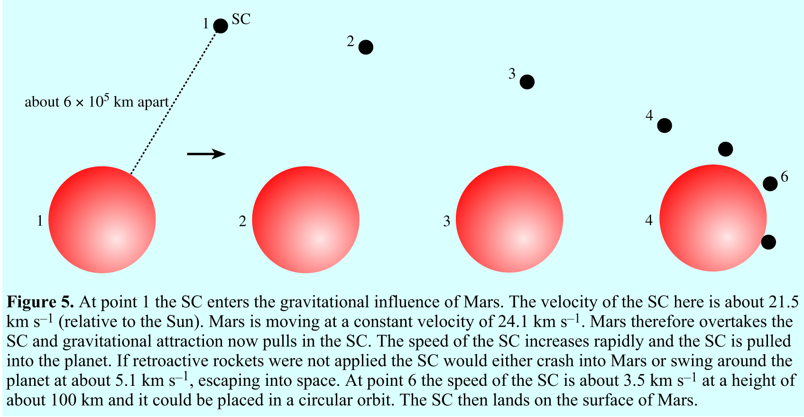
Fig. 17: Sequence showing the landing on Mars.
Using the ICP, it is easy to show that the SC will have to stay on Mars for 458 days, because it takes that long before the Earth and Mars are again in a position to initiate a second HOT maneuver to return to Earth. This time, however, Mars must be about 74 ahead of Earth when the launch takes place, allowing Earth to “catch up” with the SC in about 258 days (The HOT trajectory period divided by two).
Again, this can be checked using the ICP. The return flight involves escaping the gravity of Mars. This time the SC, after escaping the gravity of Mars, has to slow down to an orbital velocity of 21.5 km/s. To achieve this, the SC escapes the gravitational pull of Mars by leaving in the opposite direction to the orbital motion of Mars. First, the SC must leave the gravitational sphere of influence of Mars and then apply retroactive rockets to slow the orbital velocity (relative to the sun) from 24.1 km’s to 21.5 km/s. This will require a total delta V of 5.1 km/s and -2.6 km/s, for a total delta V of 7.7 km/s.
As before, the SC will be in the vicinity of the Earth in about 256 days, approaching the Earth with a velocity of 32.7 km/s, or about 2.9km/s faster than the orbital velocity of the Earth. The Earth will pull in the SC, just like Mars did, and if no retroactive rockets are used the SC would fall into the Earth with a velocity of about {2.9² + 11.2²}^{1/2} km/s, or 11.6 km/s (see website ).
This is a little larger than the escape velocity of 11.2 km/s. So our delta V is about 11.6 km/h. (Of course, NASA might decide to use the atmosphere to slow down the SC).
According to the ICP, we find that if we had left on about July 13, 2005, it would have been possible to connect with Mars, as planned . We would have returned to Earth 978 days later, on about March 10, 2008, a travel time of about 2.7 years! The reader is encouraged to check these dates using the ICP as follows:
Adjust the Earth to Mars section (Go date) to July 13. 2005. Adjust the perihelion radius to 1.0 (sometimes .99 is better), then under “Mars to Earth” adjust the “go date” to June 29, 2007. Study the configuration before starting the program. You can check all the dates and the number of days that pass by stopping the action at any time.
The energy budget for Mission 1
To travel from Earth directly on the HOT trajectory will require a delta V of about 14.1 km/s. The SC arrives at the orbit of Mars with a velocity of 21.5 km/s, or about 2.6 km slower than the orbital velocity of the planet. Therefore the SC must arrive ahead of Mars and pass inside the “sphere of gravitational influence” so that the SC is pulled in (See Fig. ). The escape velocity of Mars is 5.1 km/s, therefore the delta V needed for landing the SC is (2.6-5.1) km/s, or -2.6 km/s. This is a very small delta V requirement.
Returning to Earth the SC needs to initially move in the opposite direction to the motion of Mars; first overcoming the gravity of the planet (5.1 km/s) and then “slowing down” to the apogee velocity of 21.5 km/s from the orbital velocity of 24.1 km/s, again for a total delta V of 7.7 km/s. The SC approaches the Earth with a velocity of 32.7 km/s, 2.9 km/s larger that the orbital velocity of the Earth at 29.8 km/s. The Earth’s gravity would pull it in until reached the escape velocity of 11.6 km/s when close to the Earth. if retroactive rockets (or atmospheric friction) were not used. Therefore the delta V here is only 11.6 km/s. The total delta V for the whole trip then is (14.1 + 7.7 + 11.6) km/s or 33.4 km/s. We can express the total energy as the sum of squares of the individual delta V’s in m/s, and dividing by 2 we have an energy consumption of about 2.0 x10⁸ J/kg. See Table 1.
Mission 2: A Brief Visit to Mars
In this mission the SC travels to Mars on a modified HOT trajectory, lands on the planet for 30 days only, and then returns to Earth by way of a trajectory that has a high eccentricity. For the sake of simplicity we have the SC approach Mars along the regular HOT trajectory but intersecting the orbit of Mars 30 days earlier. The SC lands on Mars and stays on Mars for 30 days and then leaves at the aphelion point.
On the return trip the SC may cross the orbit of Venus and could even be inside the orbit of Mercury for a brief time. Use the ICP to design different times for staying on the planet and come back on various trajectories. For example, the interactive program can be used to plan journeys for a flyby of Venus and/or Mercury.
This scenario was rejected by NASA because it would be too energy-intensive for just a brief stay on the planet. However, the scenario, unlike the other two, provides a good context for discussing a number of interesting and challenging situations. It also lends itself to having students plan their own journey to Mars.
Mission 2 to Mars will be almost identical to a full HOT trajectory, with the exception of initial separation of Earth and Mars. Mars will have to be about 46° ahead of the Earth, rather than 44° in order to connect with the planet within the region of gravitational influence about 30 days before apogee.
The velocity of the SC at perigee, as for mission 1, must be 32.7 km/s, so that delta V is 2.9 km/s + 11.2 km/s, or 14.1 km/s, as before. We assume that the velocity upon arrival in the region of the gravitational influence of Mars is also about 21.5 km/s. The period of the trajectory is again 518 days and therefore the time of travel (518/2 - 30) days, or about 226 days. The delta V for matching the orbital velocity of Mars will again be about 2.5 km/s.
Here we must add a note of explanation. The distance from the sun to the SC when it enters the sphere of influence of Mars, after about 226 days, can be calculated and is found to be 1.51 AU, or about (1.52-1.51) AU, or 0.01 AU from Mars. This means that the SC is only about 1x10⁹ m from Mars, almost inside the radius of the gravitational sphere of influence.
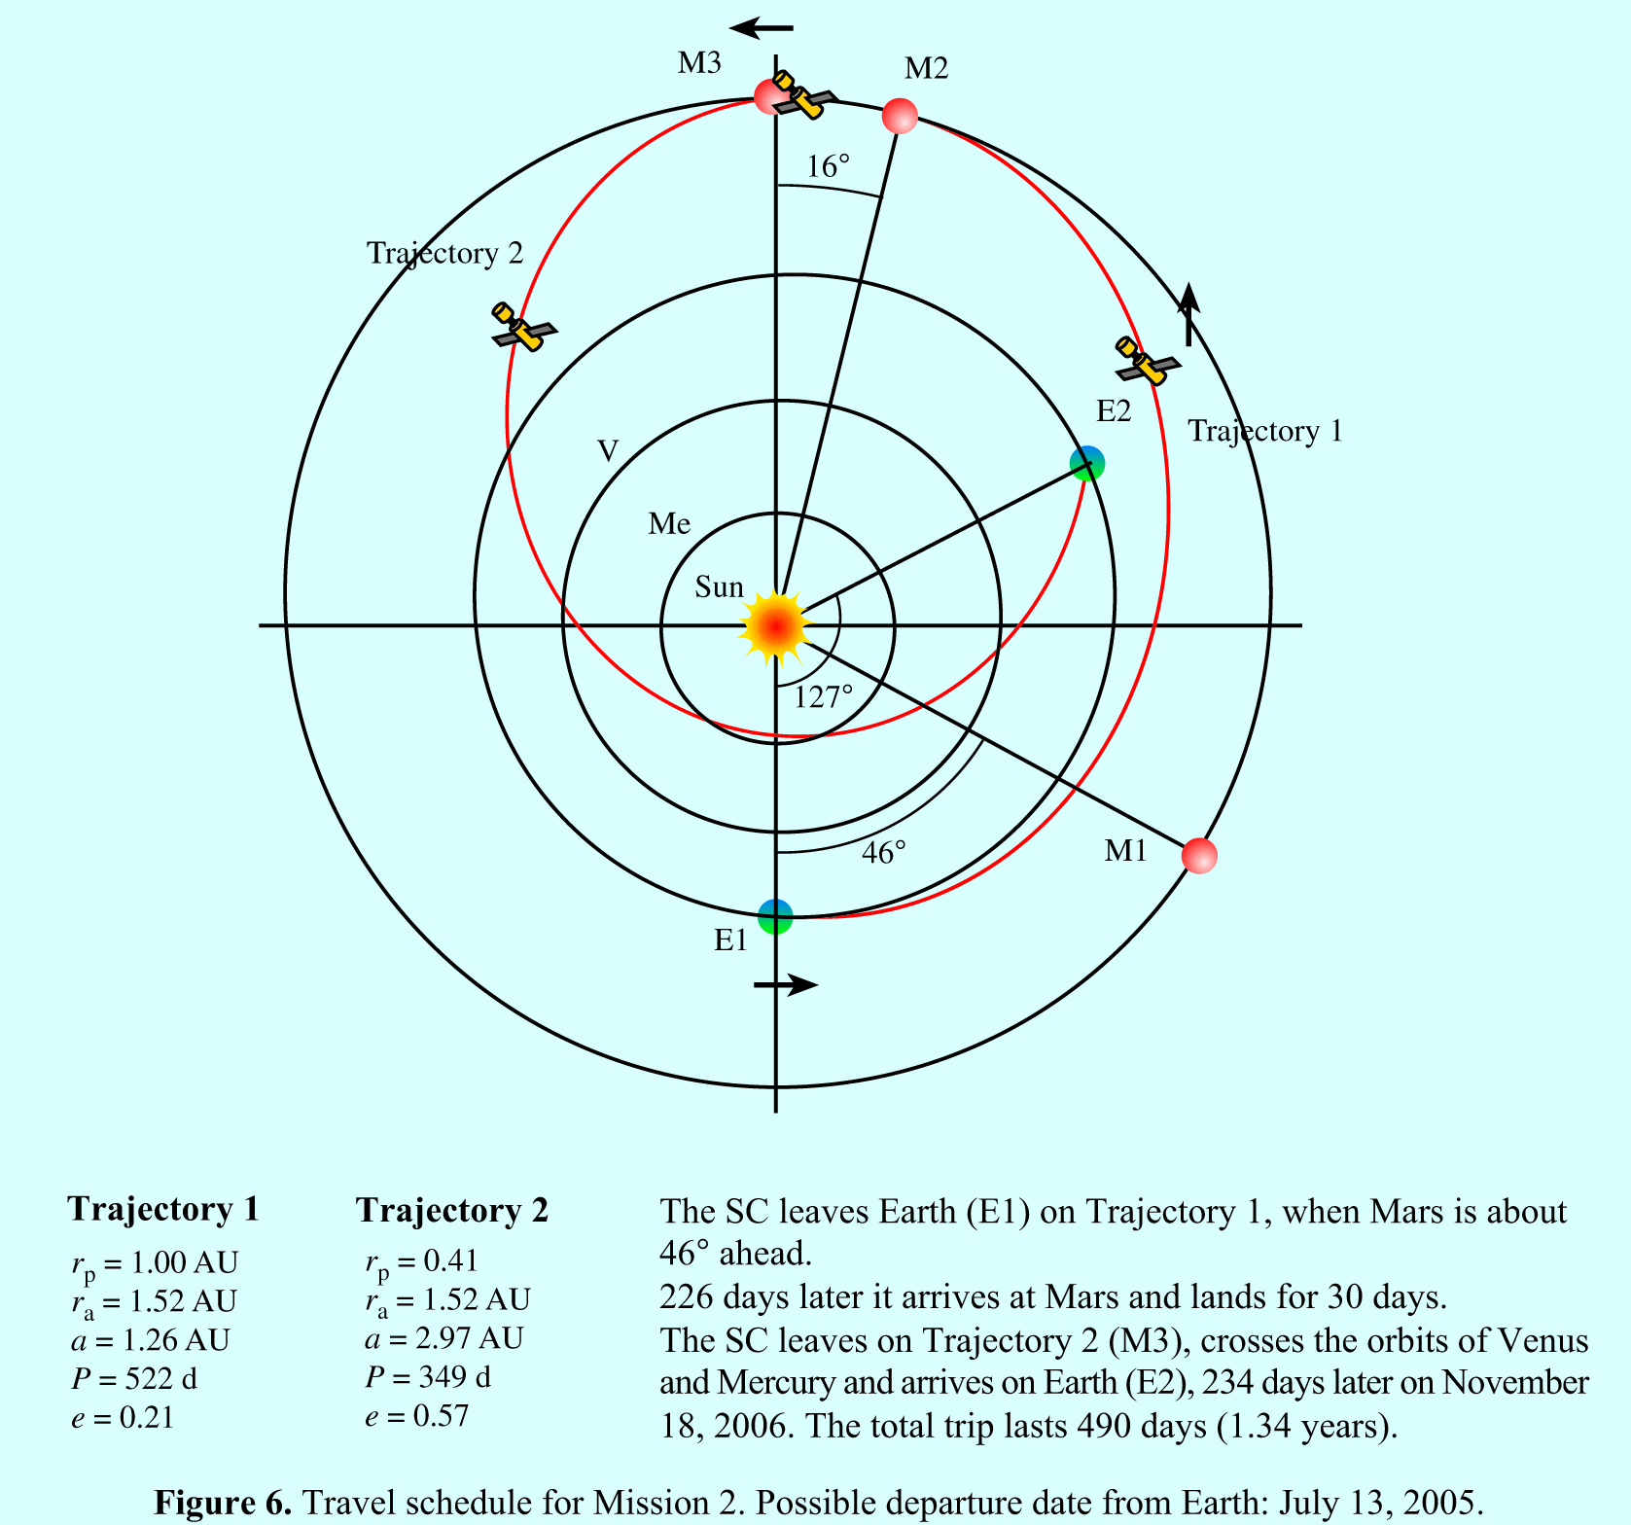

Fig. 18: Mission 2: Staying of Mars for only about 30 days.

The return trip to Earth
For Mission 2 the plan is to stay on Mars for 30 days and return on a trajectory that begins at the apogee point. It will cross the orbit of Venus and possibly the orbit of Mercury. The reader should find this return trajectory before reading any further.
After much trial and error we found that the trajectory that has a perigee of 0 .42 AU guarantees connecting with the Earth in about 235 days. Note that on the return trip the SC would come very close to the orbit of Mercury. The SC must leave Mars in opposite direction to its motion around the Sun, overcome the gravity of the planet and then slow down to 21.7 km/s. This amounts to a delta V of 7.2 km/s. The total time then for the whole trip is 490 days, or 1.34 years. This is much shorter than the 2.7 years it takes for Mission 2 and the 3.0 years for Mission 1.

The energy budget for Mission 2
Escaping Mars will require the same delta V as for Mission 2, namely 14.1 km/s. Landing on Mars will involve, as for Mission 1, a delta V of only 2.6 km/s.
Coming back, first escaping Mars (in direction opposite to its motion) takes 5.1 km/s, and then slowing down to 21.3 km/s, -2.4 km/s.
When arriving in the vicinity of Earth, first slowing down to the orbital velocity of Earth (32.8 - 29.8), or -3.0 km/s, and then overcoming the gravitational attraction of the Earth adds another delta V of -11.2 km/s, for a total of -14.2 km/s. The delta V for the whole trip then is (14.1 + 2.6 + 7.5 + 14.2) km/s = 38.3 km/s. The energy consumption then is ½ x( 14.1² + 2.6² + 7.5² + 14.2²)x10⁶ J/kg, or 2.3 x10⁸ J/kg.
Another trip using the ICP
Let us find out (by trial and error) what the trajectory must be if we left on July 13, 2005 for Mars on a HOT trajectory, stayed for 100 days and then came back on a trajectory that connects with the Earth. The time ro reach Mars would be 258 days, as before.
It is easy to adjust the parameters of the returning trajectory to find the suitable perihelion distance r_{p} so that the SC connects with the Earth. The SC lands on Mars 258 days later and stays on Mars for 100 days. The return trip then starts on July 6. 2006. After some trial and error, we find that if r_{a ,} or the closest approach to the sun on the return trip is about .26 AU (inside the orbit of Mercury!) the SC arrives back on Earth on about January 7, 2007, approximately 563 days, or 1.54 years later. The energy budget could now be worked out and compared to the two missions we have described.
Using the vis viva equation we can calculate the velocity of the SC as it is moving past the sun at the closest approach of 0.26 AU, as almost 60 km/s. The radiation energy received per unit time per unit area from the sun would be (1/.26)², or about 15 times that which we receive at the top of our atmosphere! NASA would surely reject such a trip.
Looking at Table 1 we note two important things about the energy consumption. First, the energy consumption of the two trips differ only by about 15%. Secondly, the energy required per unit mass (about 2x10⁸ J/kg) to go to Mars is enormous, when we realize that 1 kg of TNT is equivalent to 4.1x10⁶ joules of energy. So more than 90% of the load must be fuel and the “payload“ is less than 10%.

Trip | Type | Time to reach  Mars | Total Time  away | Time  on Mars | Delta V  (Total)  km/s | Energy per unit mass  J/kg
Mission1 | HOT  Trajectory  both ways | 258d  (0.70y) | 978d (2.7 y) | 460d  (1.3 y) | 14.1  2.6  7.7  11.6  Total: 33.4 | 2.0 x10⁸
Table 1: The Energy Budget and Time for the Missions:

Concluding Remarks
Few high school and first year university physics students understand the physics of traveling to a planet beyond isolated problems they solved in their textbooks. This paper in conjunction with our ICP may provide enough background and material for teachers of physics to enrich their presentation of the physics of Newtonian gravitational theory, Kepler’s laws and their application to space travel.
We did not discuss the psychological and physiological problems that long travels in a crowded surrounding, and effectively in “free fall” will present. A thorough reading of Sarah Simpson’s “Staying Sane in Space” (in the Scientific American issue mentioned), would provide enough background for a good discussion of these problems and may suggest further research. Surely, the physics of space travel as well as the technical problems of going to Mars can be solved; but whether or not we can ever solve the human aspects of such a journey is an open question. Whichever scenario NASA decides to choose, the time of travel will be more than one year. A more recent and easily accessible reference is the article “Destination Mars” by Justin Mullins in the January 31-February 6. 2004 issue of the British journal New Scientist.
Aside from the already-stated simplifications used in solving the problems (circular motion of the planets, and their coplanar positions) we also neglected to take into account the problem of the angle of approach when a trajectory intersects with the orbit of a planet (See Stinner, 2000). For the Hohmann trajectory that problem clearly does not arise since it overlaps the orbit of the planet on contact. Finally, it should be mentioned that NASA may use the braking effect of the atmosphere of Mars and that of the Earth when spacecrafts land, thus reducing the delta V factor by a significant amount for a journey.
A quick reference to Table 1 allows a comparison of the two missions plus the ICP assisted trip, based on energy requirements, time spent on Mars and the total time necessary for a return trip. This table could stimulate a lively discussion trying to balance the advantages and disadvantages of the three missions.
In 1925 the German engineer Walter Hohmann showed how to select a trajectory to a planet like Mars that would require the least energy. At that time Charles Lindbergh’s crossing of the Atlantic by a plane was still in the future and space rockets were science fiction. Hohmann was a visionary, earning the respect and admiration of the young Wernher von Braun, who later used his calculations and technical suggestions to plan the first landing on the Moon. The Hohmann orbit transfer is used by NASA, along the lines discussed in this paper. The story of Walter Hohmann provides an engaging educational link between the space visionaries of the past and the present possibilities of modern space technology. Students should be given the opportunity to participate in this adventure.

Calculations, shown in detail
Block 1:
1. To find the velocity of a body orbiting about the sun:
Use the vis viva equation which is based on the total energy of an orbiting body being
E_{total} = ½ m v² - G M_{s} m / r
This total energy can be shown to be equal to - G M_{s} m / 2a
Therefore, v_{r} = {GM _{s} ( 2 / r - 1/a)}^{1/2} , where G is the Universal Gravitational constant.
M_{s} is the mass of the Sun. These values are 6.67x10⁻¹¹ m³ / s² .kg, and 2.00x10³⁰ kg, respectively. This very important and universal equation is generally known among astronomers as the vis viva equation. See Fig.2.
2. It is more convenient to write the vis viva equation in the following form:
v_{r} = 29.8 x ( 2/r - 1/a)^{1/2} (km/s)
where the “average” velocity of the Earth is 29.8 km/s and a and r are given in astronomical units AU. The distance to the sun from the Earth is 1 AU (1.50x10¹¹ m).
3. The period of a body moving around the sun is given by Kepler’s third law:
P = P_{E} a^{3/2}, where P_{E} is the period of the Earth and a is the semi-major axis

We then write:
P = 365 a^{3/2}, where we will take 365 days as the period of the Earth.
Block 2:
For Mission 2:
Trajectory 1 is the same as the HOT trajectory we calculated for Mission 1, except that we must leave Earth when Mars is 46 ahead of the Earth in order to approach the planet about 30 days before arriving at the aphelion point. The trip will last about 226 days and 30 days later the SC returns on trajectory 2.
Trajectory 2:
This is a more complicated orbit to calculate than the simple HOT trajectory. The time of transit along an ellipse can be calculated from Kepler’s second law and is equal to the area under the portion of the ellipse determined by the angle  and divided by the total area of the ellipse. The geometric solution to this problem was worked out by Kepler, but it took the power of the calculus to provide an analytical solution. The area of an ellipse is simply π a b.
Therefore, the transit time
T_{transit} = Area A swept out by r divided by the total area of the ellipse times the period of the planet:
t = {A / πab} P
A fairly straight-forward geometric argument leads to Kepler’s equation:
T_{transit} = 365 a^{3/2} ( E - e sin )/ 2π, where
E = cos ⁻¹ { ( e + cos θ) /(1 + e cos θ) }
(Care must be taken, however, to express E in radians!)
There are many choices we can make in deciding Trajectory 2. Our perihelion distance, r_{p}, of course, is fixed at 1.52 AU. The perihelion distance, r_{p}, is constrained by how close we dare to come to the sun. If we chose to go deep inside the orbit of Venus, say for
r_{a} = .30 AU, the radiation energy from the sun would be (1 / .3)² times that on Earth, or about 11 times greater. We found that a trajectory that has a perigee of 0.42 AU (very close to the orbit of Mercury) connects with the Earth in about 235 days. See our website for details for this calculation.
References:
Abell, George, (1969). Exploration of the Universe, (1969), Holt, Rinehart and Winston
Bate, Roger et al,(1971). Fundamentals of Astrodynamics, Dover Publications, New York.
Marion, B. and Thornton, S. (1988). Classical Dynamics, HGB Academic Press.
Musser, G. and Alpert. M. (2000). HOW TO GO TO MARS, Scientific American.
Volume 282, No. 3, 44-51.
Simson, S. (2000) STAYING SANE IN SPACE . Scientific American,
Volume 282, No. 3, 61-63.
Singer, F. (2000). TO MARS BY WAY OF ITS MOONS, Scientific American,
Volume 282, No. 3, 56-57.
Stinner, A. (2000). Hitchhiking on an Asteroid: A large Context Problem, Physics in Canada. January/February. 27-42.
Zubrin, R. (2000). THE MARS DIRECTION. Scientific American, Volume 282, No. 3, 52-55.
New Scientist (January 31-February 6, 2004).
http://www.globeandmail.com/servlet/articleNews/TPStory/LAC/20040115/SPACECANADA

